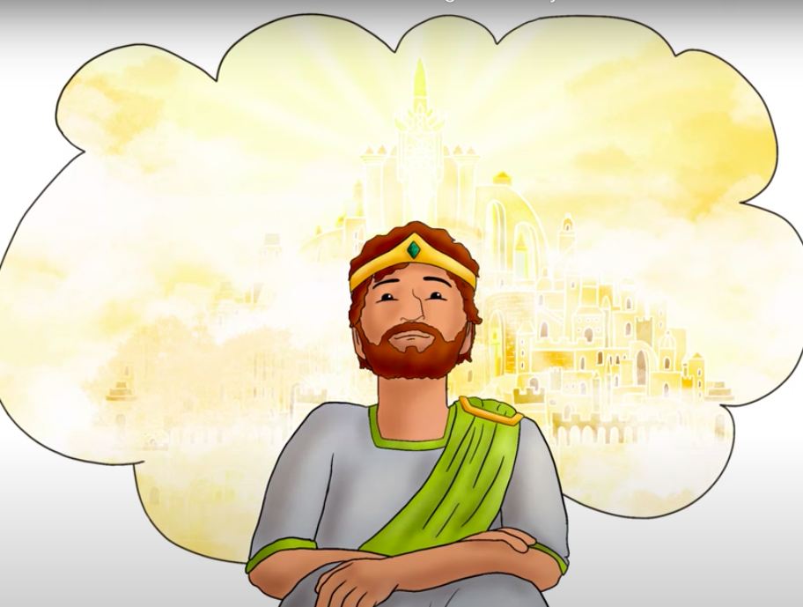
For Digital Lesson: CanyonChurch.com/Kids Kings & Prophets Lesson 10 Pg.1
You Tube video: https://www.youtube.com/watch?v=H2T5AgKSsqM (4:12)
King David Finds Out God’s House Is To Be Built in Stages
by Bible Stories for the Young

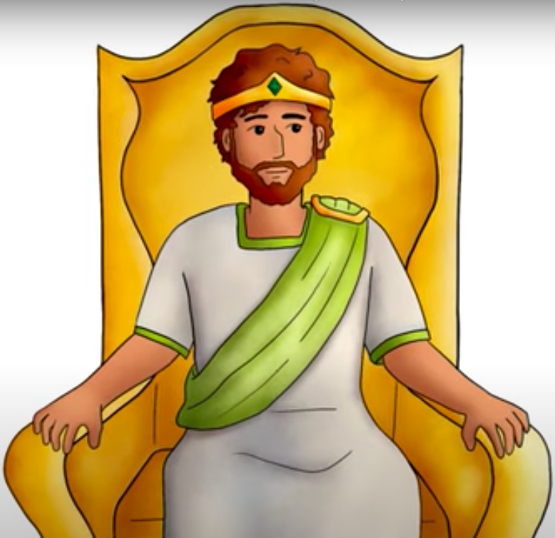
Lesson 10: GOD PROMISES DAVID TO BUILD HIS FOREVER KINGDOM
(1st Chronicles 17, 2 Samuel 7)

The Bible says that God had helped King David to defeat Israel’s enemies. Then David rested from all the fighting.

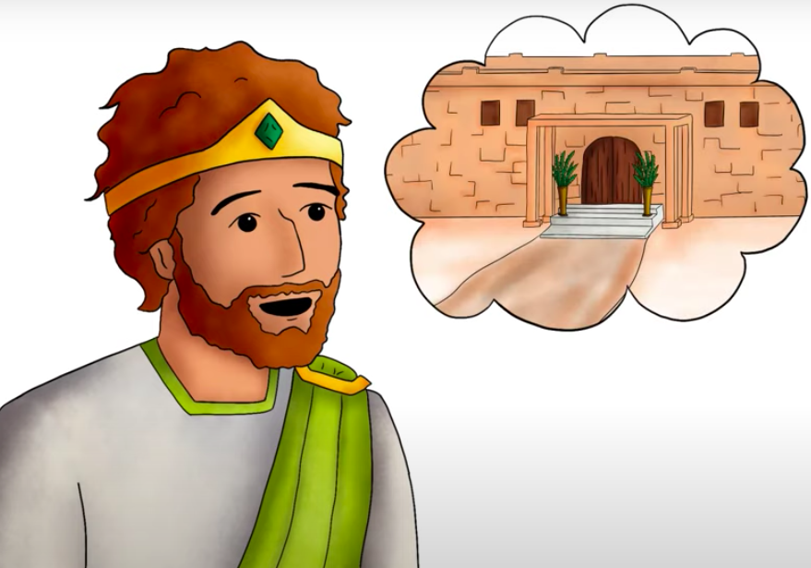

One day David was sitting in his big beautiful palace. He said to Nathan the Prophet, “I am living in this big beautiful palace built on a strong foundation with strong safe walls.”

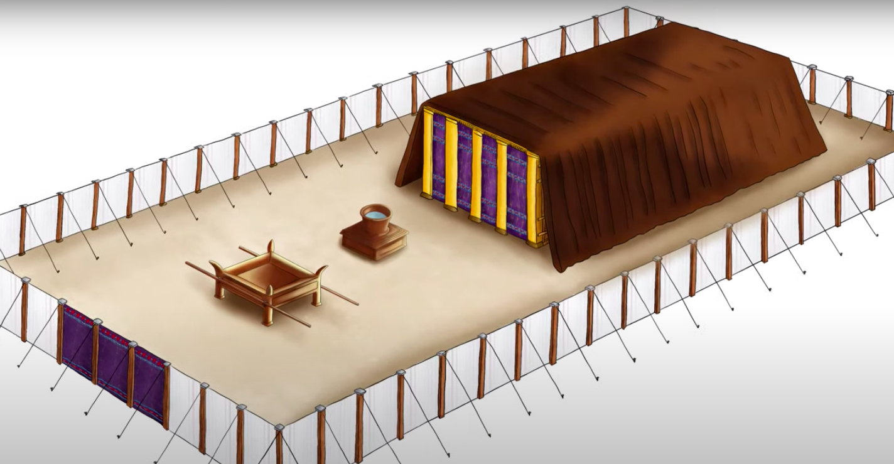
“But God is still living in a tent. That’s not right. God has only had a tent since way back when Moses made the tabernacle.
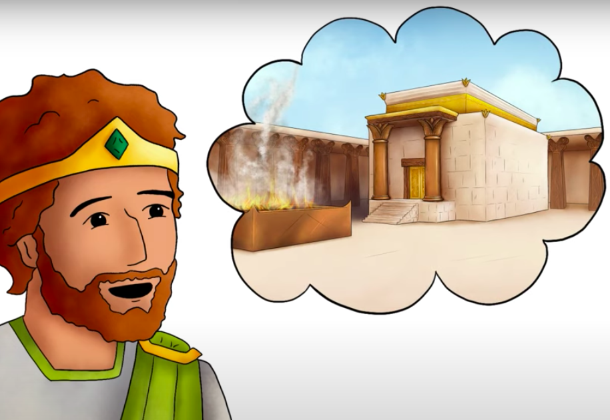

I want to build a nice strong house for God.”
Nathan replied to the king, “Go ahead and do it.”

But that night God told Nathan, “Go and tell my servant David that this is what God says. ‘Since I brought the Israelites out of Egypt, I have dwelt in a tabernacle.’”
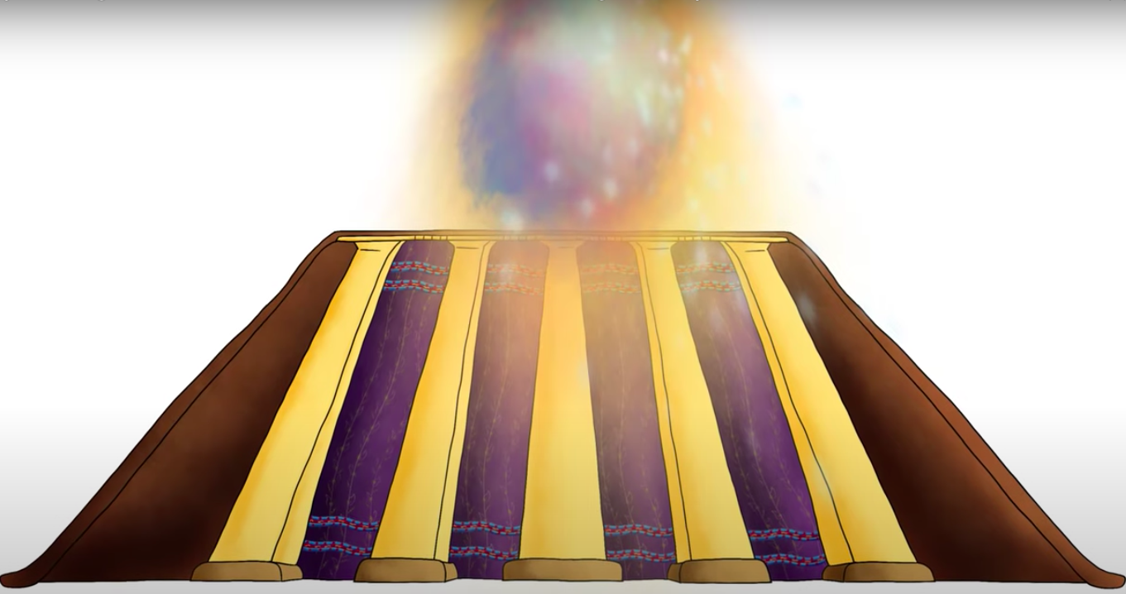

“I have been moving from place to place with the tabernacle tent as my home. Did I ever say I wanted you to build me a house of wood?” (The answer is “No.”)
OT5 Kids’ Notebook
Visuals & Narrative from BibleStoriesOnLine.com

Lesson 10 Pg. 2

God said to David, “I took you from the pasture tending the sheep. I made you the leader over my people Israel. I have always been with you. Now I will make your name great like the names of the greatest men on earth.”
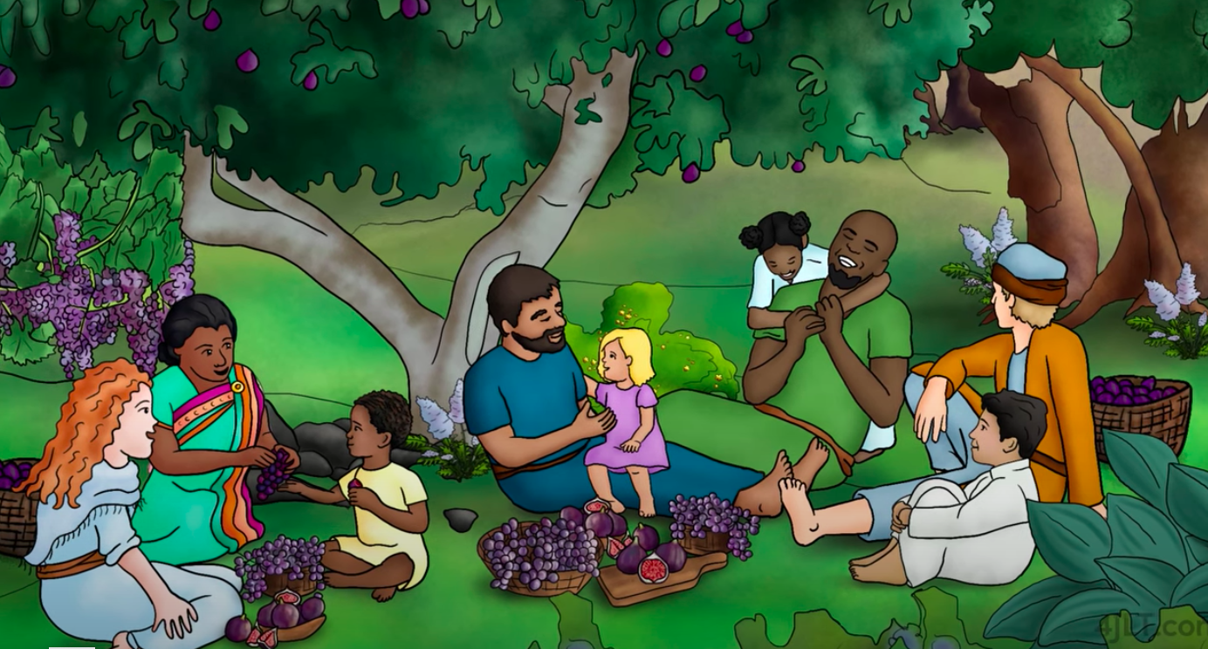

“And I will make a place for my people so they can have a home of their own. Wicked people won’t be able to keep you down. And I will give you rest from all your enemies.”

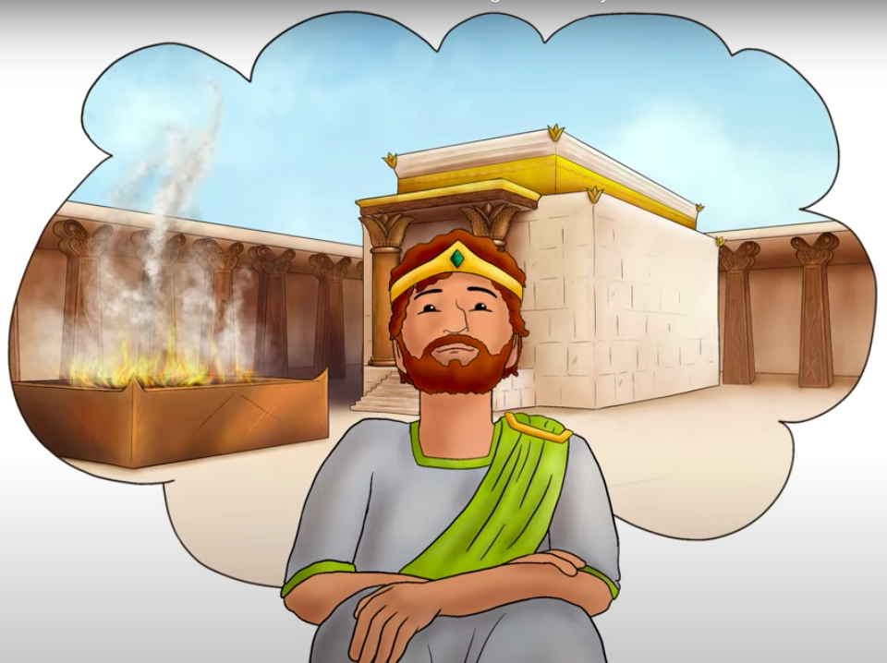

“I will establish a house for you. When your days are over, I will raise up someone from your family. He will build a house for my name. His kingdom will be forever. I will be His Father and He will be my Son. So, your house will last forever.”
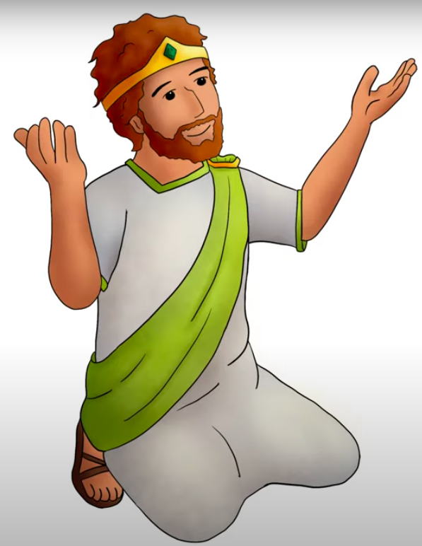

God promised David that SOMEONE FROM HIS FAMILY WILL SIT ON DAVID’S THRONE AS THE FOREVER KING!
David prayed to God. David was so happy that God had given
him this wonderful promise. God had told him about His
plan for the future!

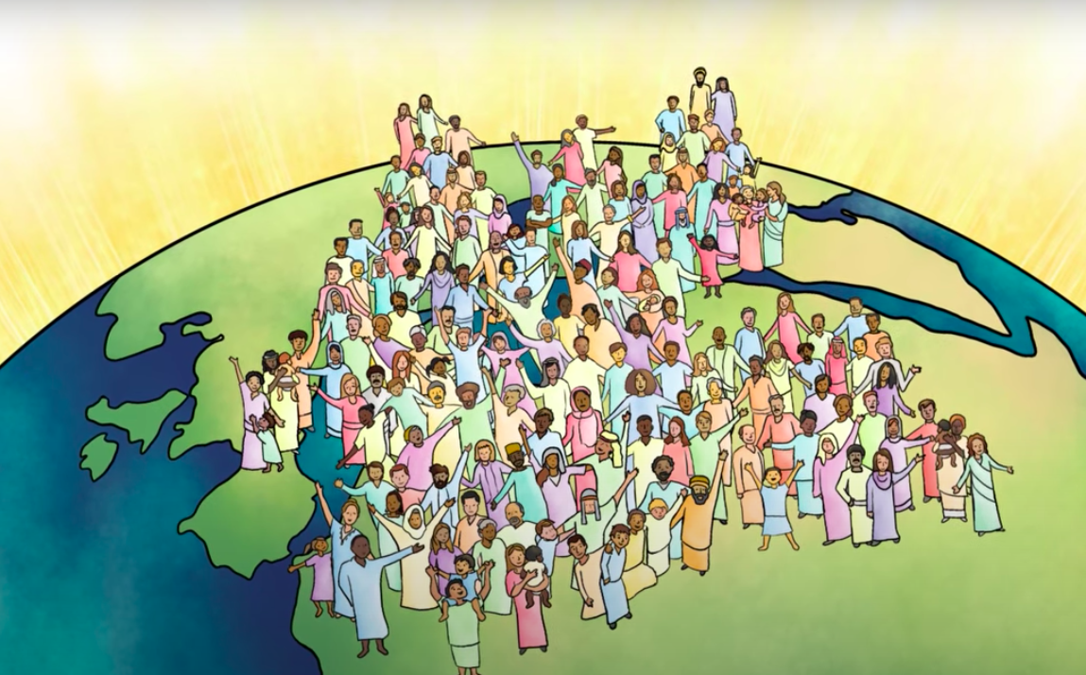
David praised God for making this COVENANT with him. He praised God for His promise to build His forever house.

David said, “Do as You promised, so that your name will be great forever!”
God keeps His promises. Later, God sent His Son Jesus to be the FOREVER KING!
OT5 Kids’ Notebook
Visuals & Narrative from BibleStoriesOnLine.com

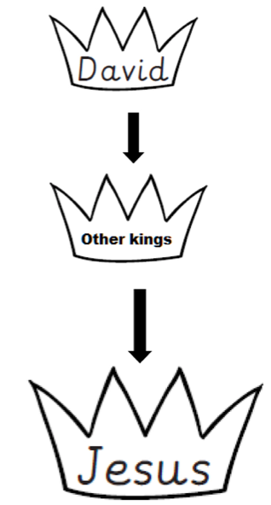
PRIMARY GRADES ACTIVITY
Lesson 10 Pg. 3

COLOR THE PICTURE OF GOD’S PROMISE TO DAVID

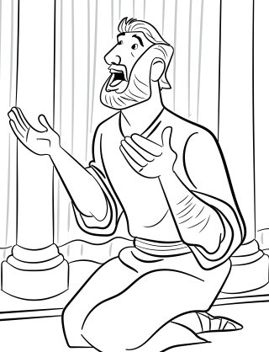
OT5 Kids’ Notebook
Picture from Gospel Project

Lesson 10 Pg. 4
UPPER GRADES ACTIVITY

God made a COVENANT (or PROMISE) with DAVID.

THINK ABOUT THIS:

David loved God so much that he wanted to build him a “House” or “Temple.” But God had a better plan. He wanted David’s son to build Him a Temple. Then He promised David, “I will build your house forever.”

Read 2nd Samuel 7:16
“Your house and your kingdom will endure forever before me; your throne will be established forever.’”

- What did God mean when he said “David’s house?” David’s

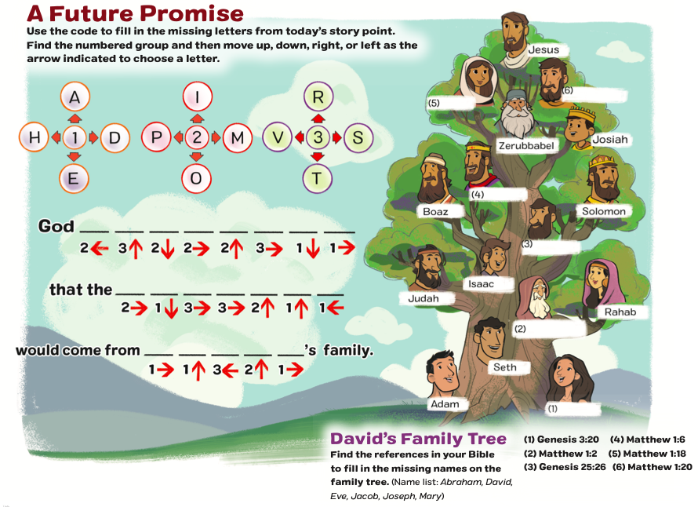
- Who is God’s chosen one (Messiah) that will reign forever?
DAVID’S FAMILY TREE
OT5 Kids’ Notebook
Activity from Gospel Project
(Fill in the names: Abraham, David, Eve,
Jacob, Joseph, Mary)

